**House list test case**

**Goal:**

As a tester, I want to verify if the House List form works correctly to show me if the formulary is appropriately filled.

**Background:**

House list page is responsible to verify and show available houses according to the user specifications.

**Steps to Reproduce**

1. Go to <https://www.find-a-house.nl/en/home> and click on the menu bar.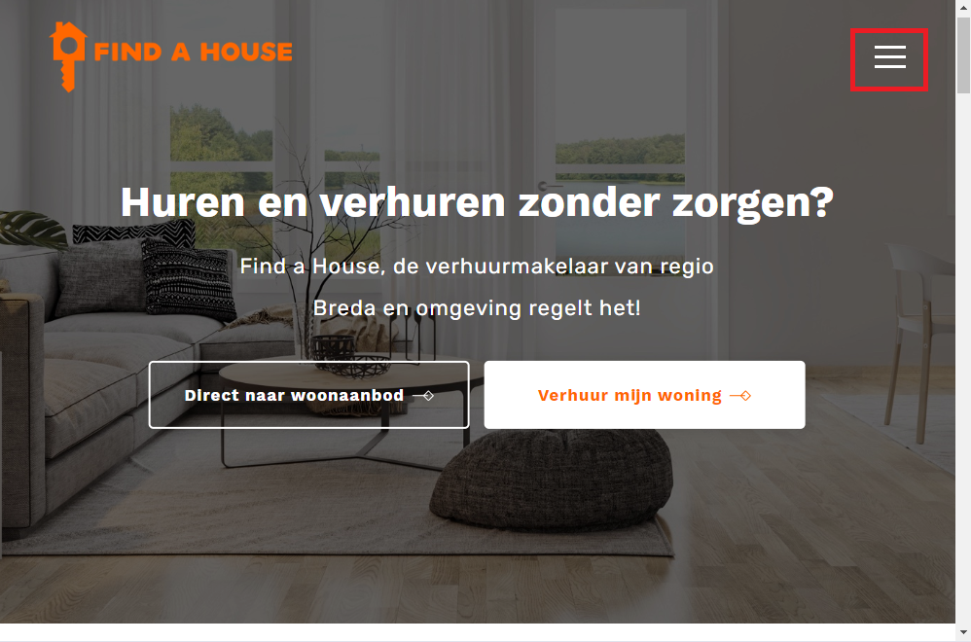

2. Click at the “Inloggen” Button to open the Login form.



3. Type an email account and password and click at the button “Inloggen”.

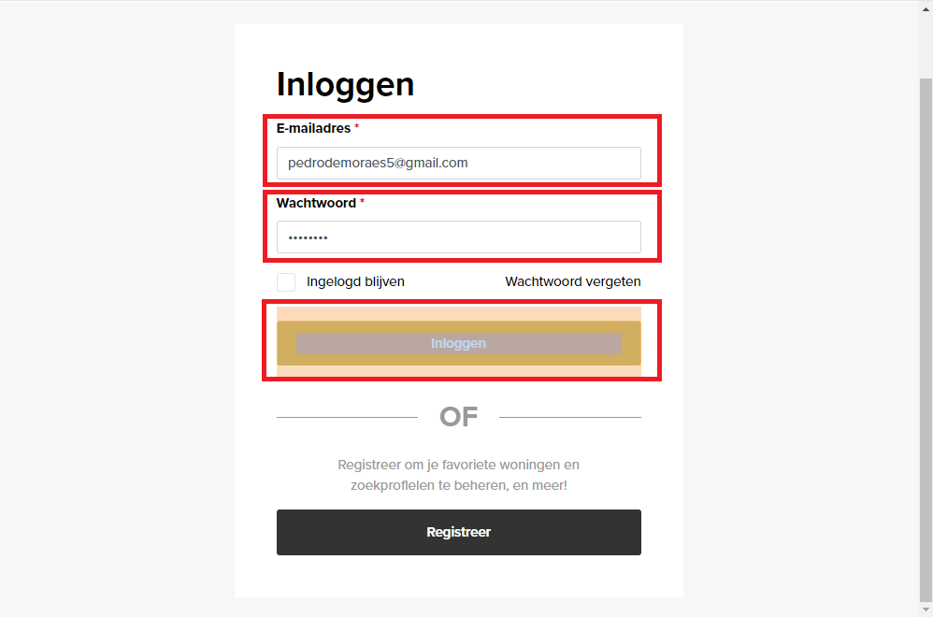

4. Dashboard page will be open then click on the button “Terug naar de website” .

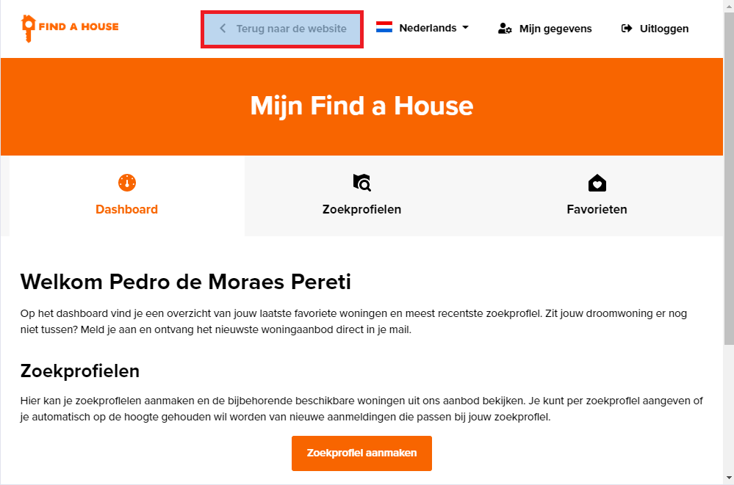

5. The page will be redirected for the principal menu.

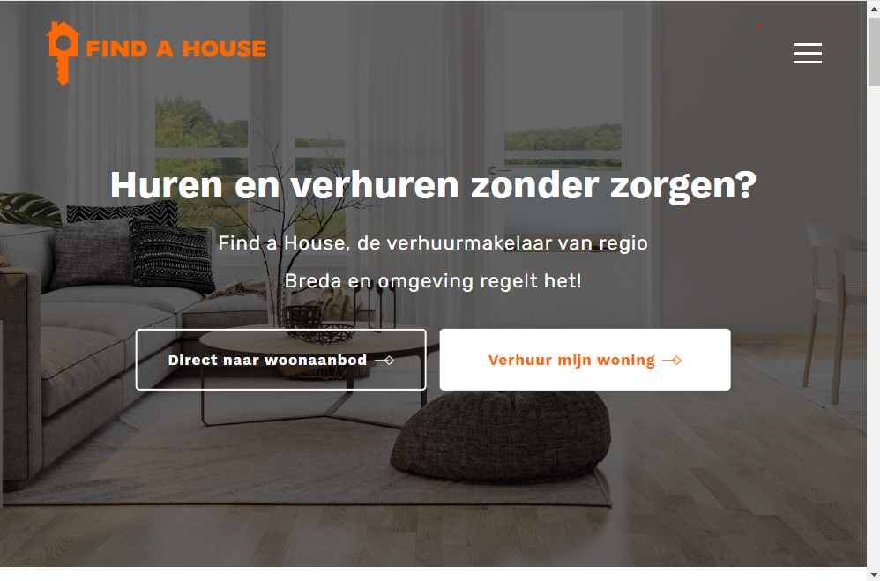

6. After back to the principal menu, the “Bar menu” should be open one more time.



7. Click on the button Aanbod.

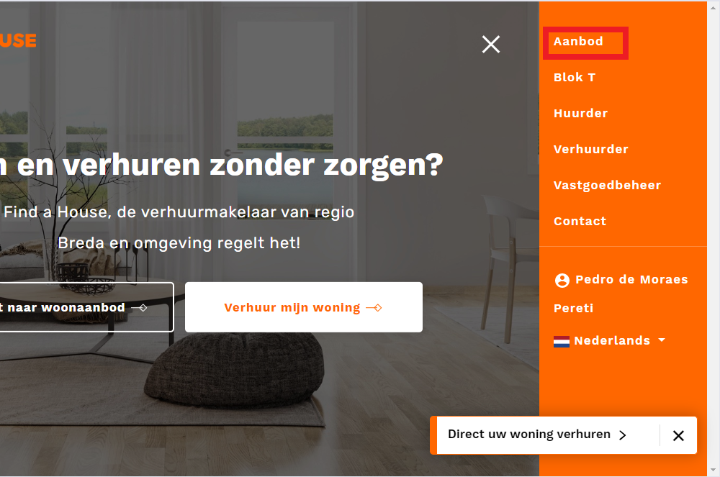

8. Fill the fields and choose an option. The search is automatic finished.

